

|  |  |  |
| --- | --- | --- |
| **Guide Name** | | **Panel Head** |
|  | Dr. S. Priya | Dr. T. Manoranjitham |
|  |  |  |
|  | **Faculty Advisor** | **Project Domain** |
|  | Mrs. R. Brindha | Agriculture |
| M |  |  |
|  | **Student(s) Details: Name** | **Passport size photo(s)** |
|  | 1. Aksh Dharmesh Kalyani 2. Nipun Chaurasia |  |
|  |  |  |

Registration Number(s)

1. RA2011003010525

2. RA2011003010536

**Email ID(s)&Mobile Number(s)**

|  |  |
| --- | --- |
| 1: ak6155@srmist.edu.in | 2: nc1135@srmist.edu.in |
| 9409258555 | 8953399426 |

**Abstract Architecture Diagram**

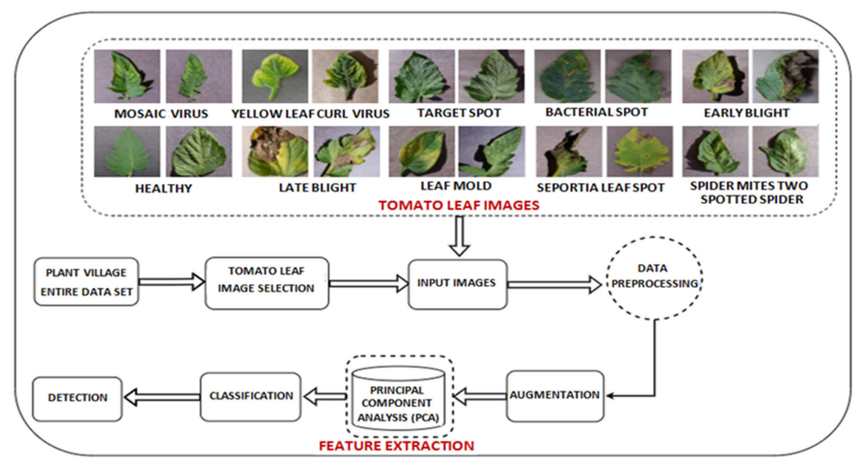

In India, where almost 70% of the population depends on agriculture for a living, it is extremely important. To reduce crop losses, plant diseases must be identified as soon as possible. On the other hand, manual disease monitoring is time-consuming, labour-intensive, and demands specific knowledge. This study uses machine learning and image processing methods to identify plant illnesses from leaf photos in an effort to overcome these difficulties.

Leaf images are processed using image processing, a subset of signal processing, to extract pertinent information. Automatic decision-making based on training data is made possible by machine learning, a branch of artificial intelligence. The project's main goal is to classify diseases using characteristics including leaf colour, damage level, leaf area, and textural parameters.

**Significance of the Project Conclusion**

"A Comprehensive Study on Leaf Disease Prediction Using Artificial Intelligence and Deep Neural Networks" holds profound significance as it revolutionizes agriculture, particularly in India, where it plays a pivotal role in the livelihoods of millions. By harnessing AI and deep learning, this innovative project offers early disease detection, promoting food security, sustainable agriculture, and economic growth. Its user-friendly interface, bridging the digital divide, and setting new standards in the agricultural sector.

A Comprehensive Study on Leaf  Disease Prediction Using Artificial Intelligence and Deep Neural Networks represents a significant advancement in the field of agriculture, particularly in India, where agriculture plays a crucial role in the livelihoods of millions. This project addresses the challenges of plant disease identification, offering a practical and innovative solution that holds the potential to revolutionize farming practices.

**Conference/Journal Publication Details (If Any)**

Under Process